Your Band  
NEWSLETTER

December 15, 2018

# Stock Market trading-Commerce seminar

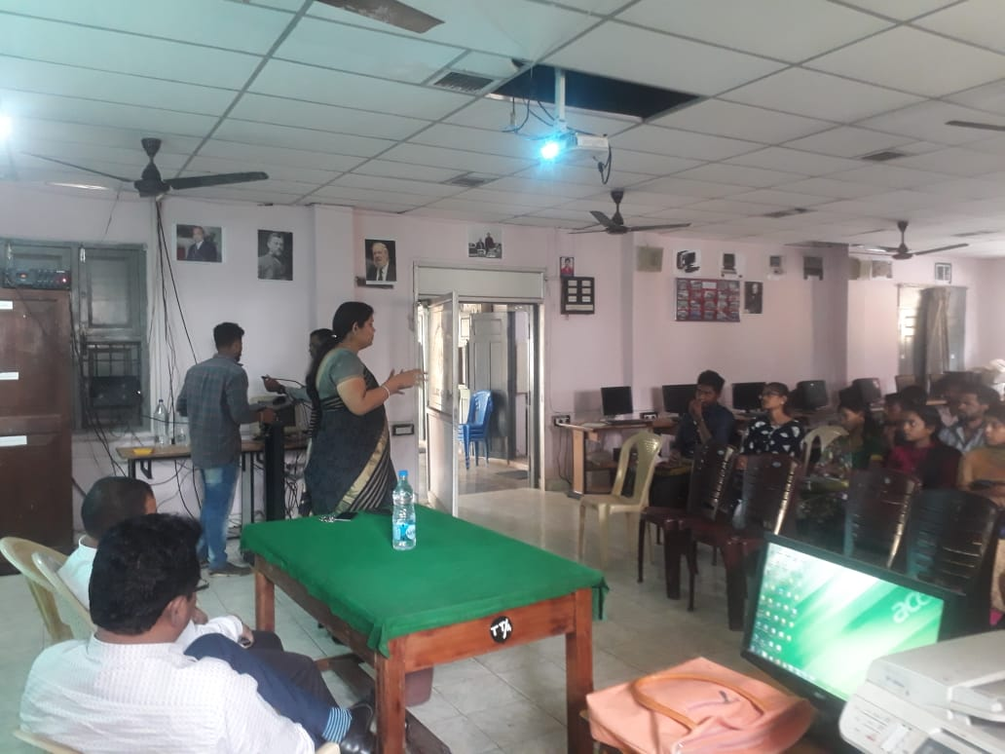

## A big big thank you!

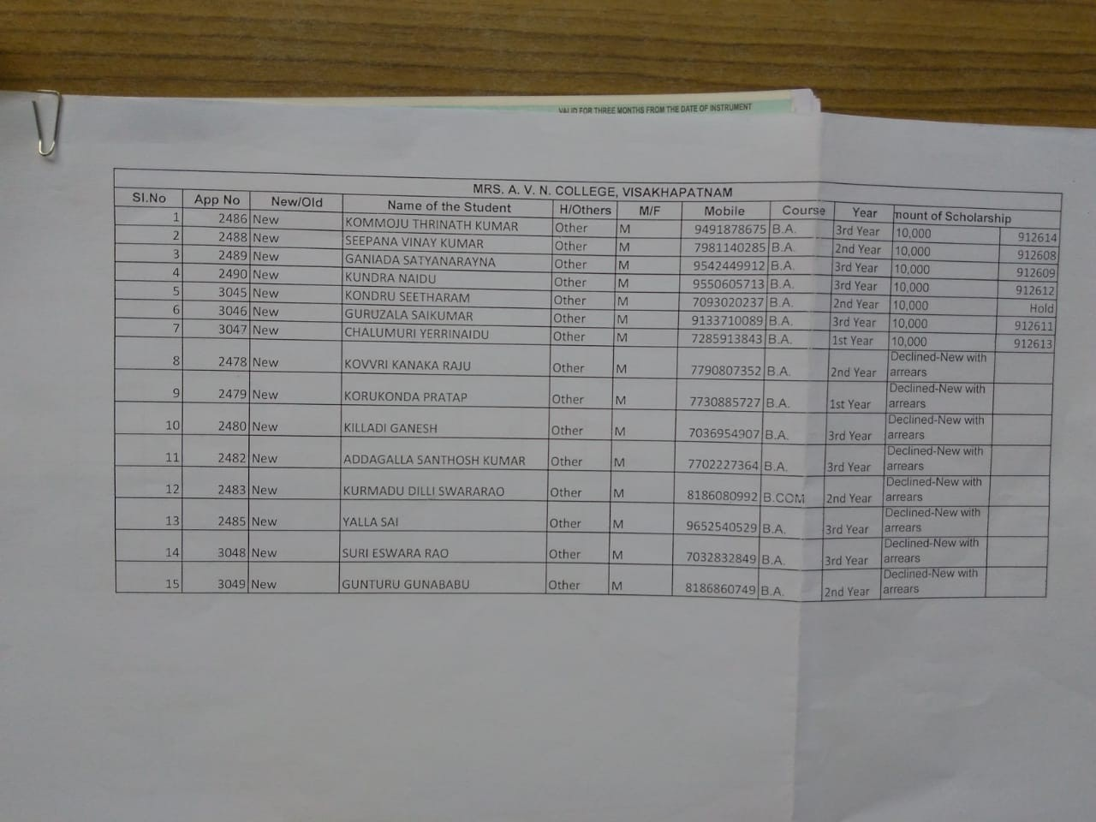

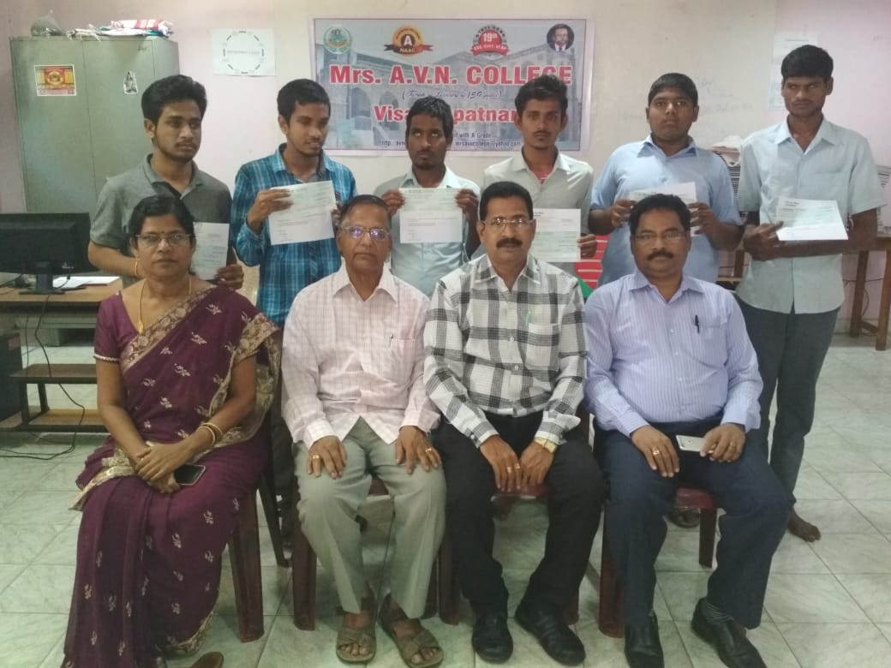

Physically challenged students- Scholarships